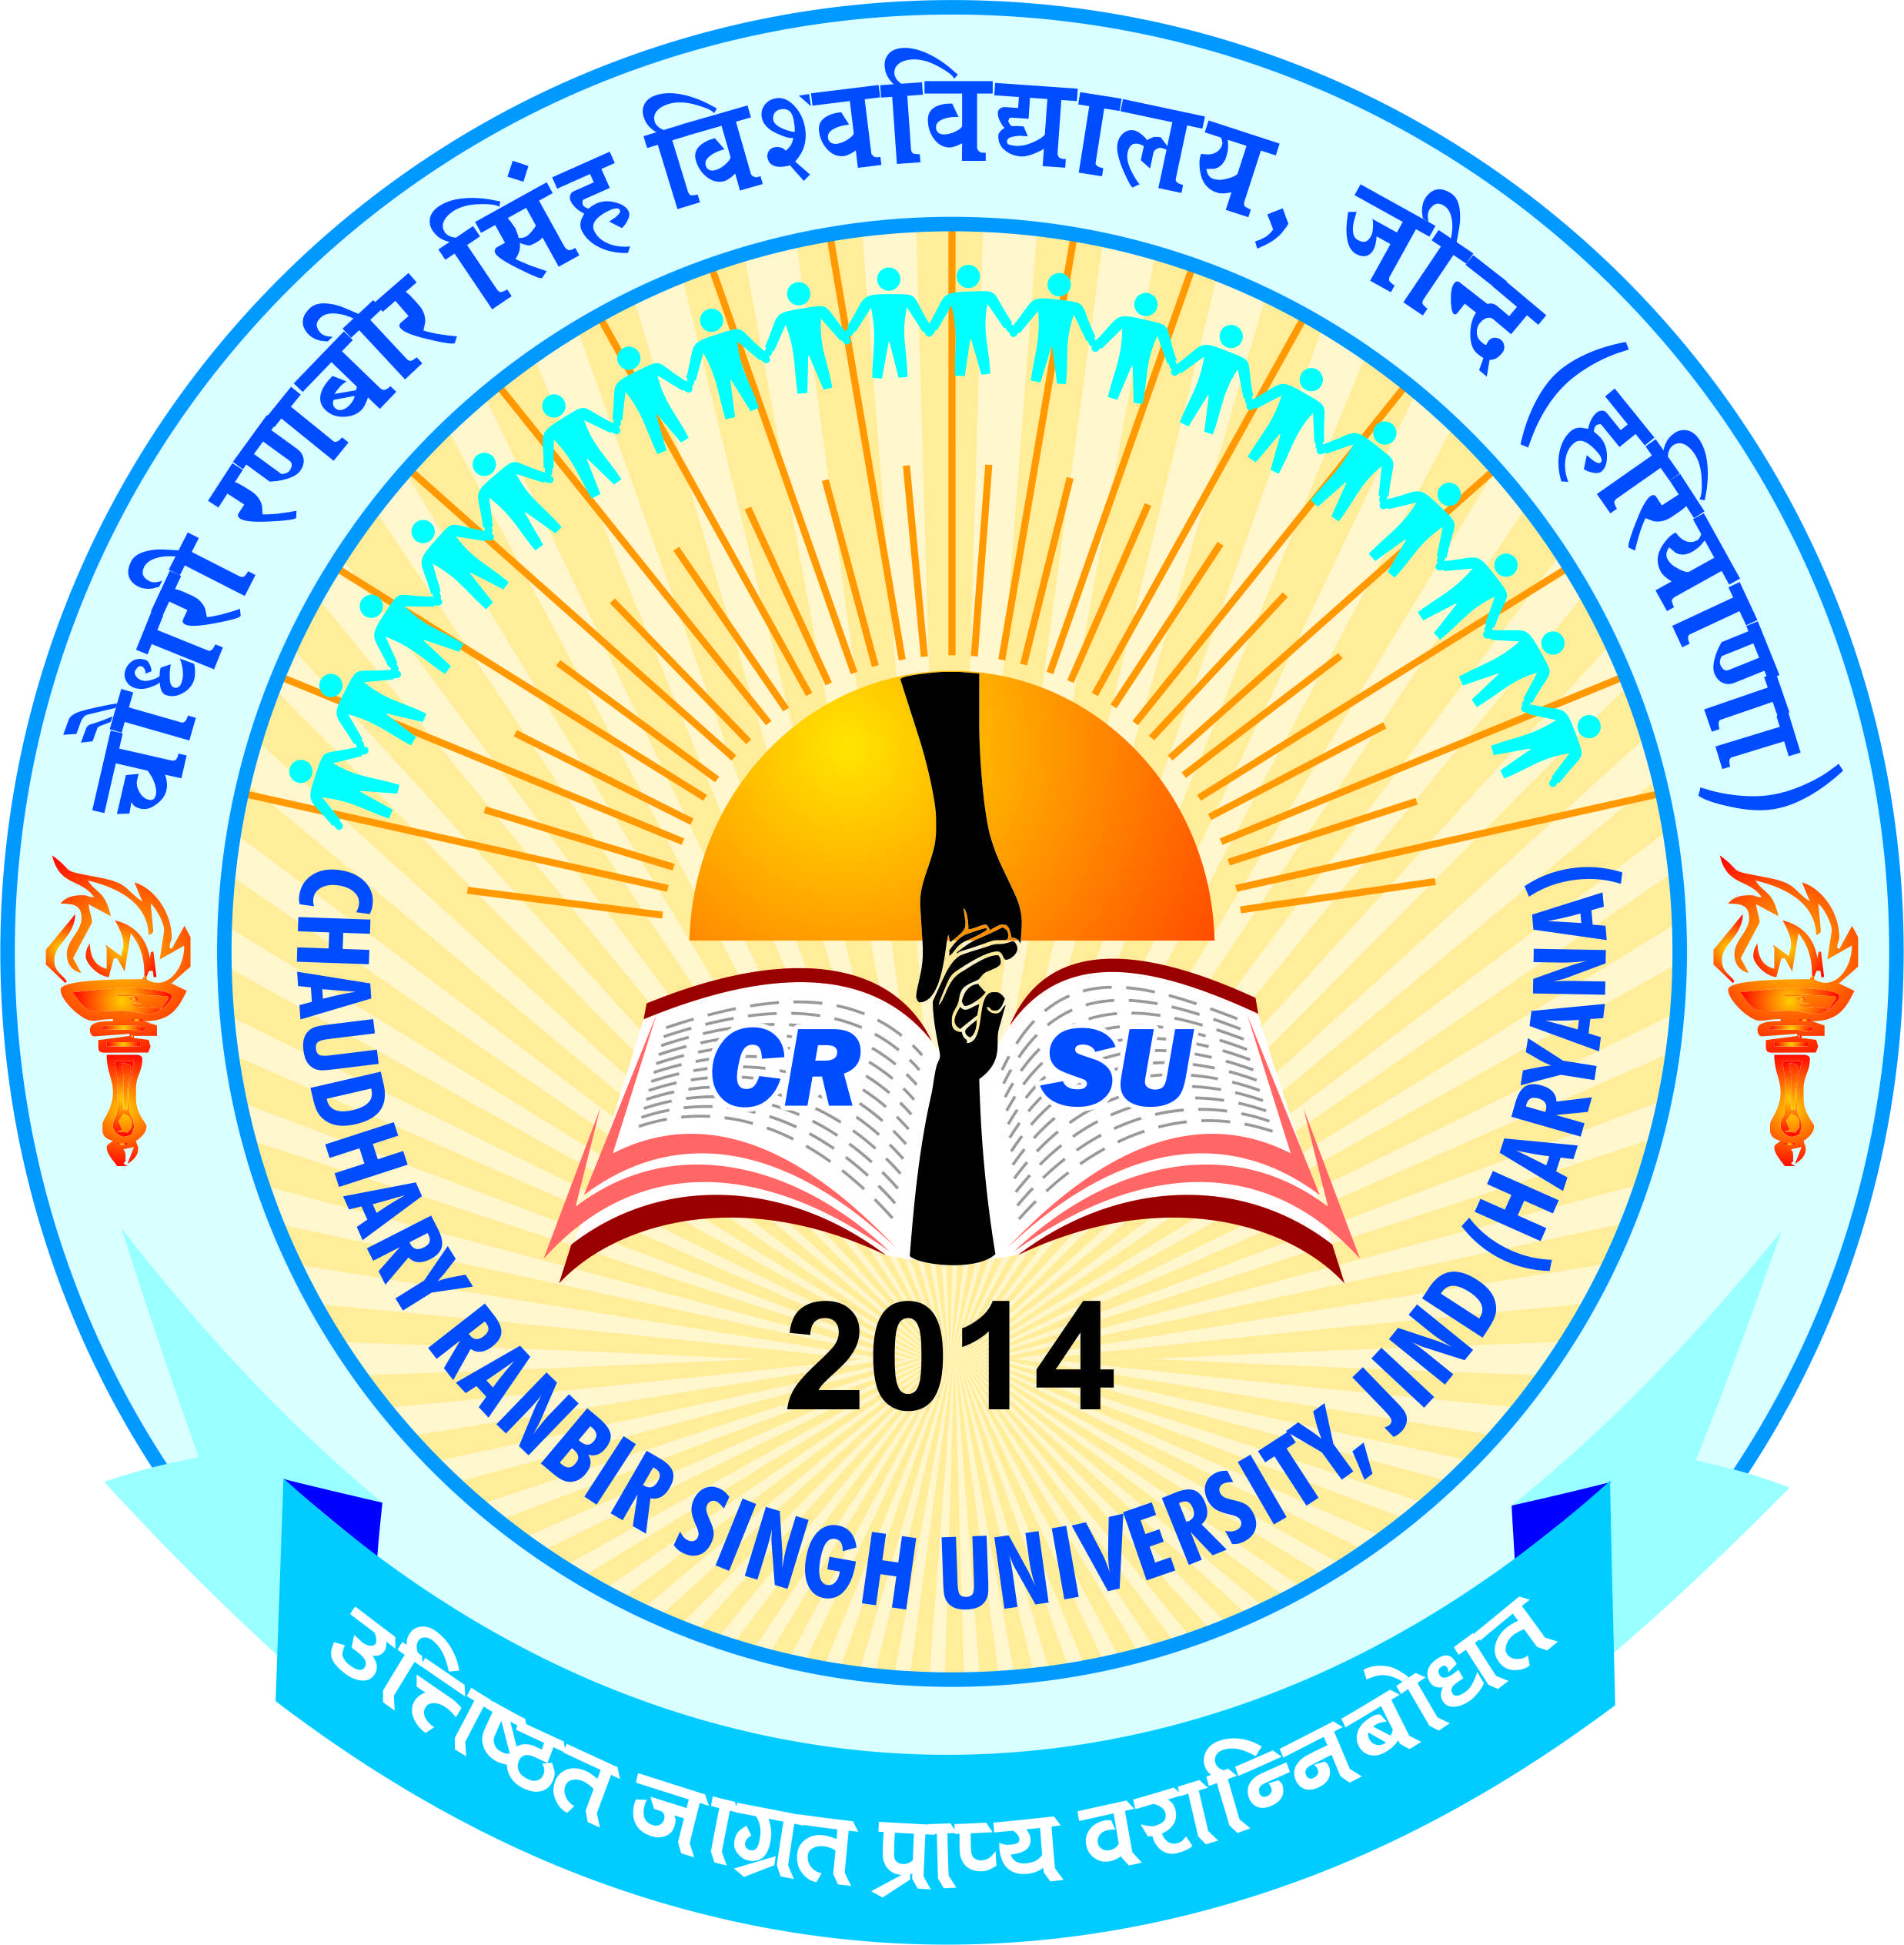 | pkS/kjh j.kchj flag fo'ofo|ky;]thUn  Chaudhary Ranbir Singh University, Jind  (Established by the State Legislature Act 28 of 2014 and recognized U/S 2(f) & 12-B by UGC Act 1956) | 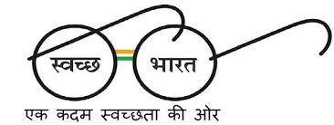

Admission for M.Ed. (Regular) Two Year (4 Semester) Course for
Academic Session 2018-19

Online applications are invited from candidates for admission to M.Ed. (Regular) Two Year (4 Semester) Course for the Academic Session 2018-19 in the Colleges of Education affiliated to this University offering M.Ed. Course for the Academic Session 2018-19. The Prospectus containing all the details will be available on University website i.e. www.crsu.ac.in or http://www.hrymed.com w.e.f. 19-10-2018. The Opening Date of Online Registration is 19-10-2018 and Closing Date is 29-10-2018.

REGISTRAR

